Shabbos Stories For
Parshas nitzavim-vayeilech 5786
Volume 17, Issue 52 23 Elul/September 5, 2026
Printed L’illuy nishmas Nechama bas R’ Noach, a”h
The Irish Cop and the Lubavitcher Rebbe

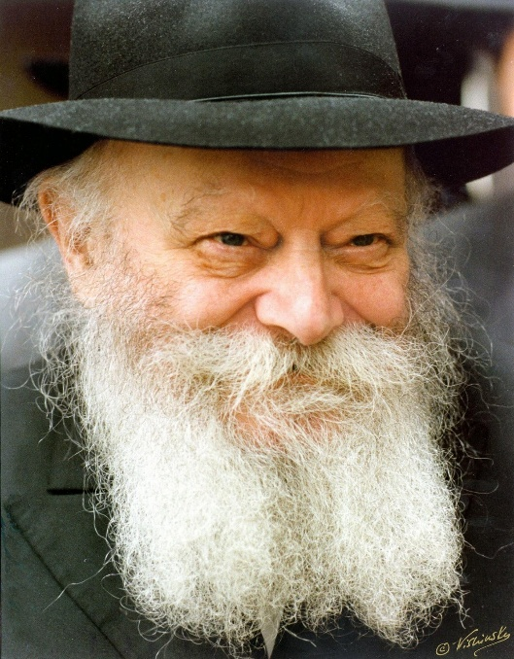

Many people have talked their way out of receiving a traffic ticket using all sorts of excuses, ranging from urgent emergencies to elaborate fabrications. But perhaps no one ever had a better, more heartwarming excuse than a woman from Crown Heights who found herself pulled over by a New York City traffic officer. Standing outside her open car window and watching her fumble nervously through her handbag for her driver’s license, the officer’s eyes caught sight of a picture tucked inside her purse - a photo of the Lubavitcher Rebbe, R’ Menachem Mendel Schneerson zt”l.
Pausing, the officer looked at her and asked if she was a follower of that Rabbi. When she replied that she was, he calmly closed his ticket book and announced that he wouldn’t be giving her a ticket after all. Touched by her visible surprise, he offered to share the reason why, mentioning that while it was his absolute favorite story, he had never actually told it to a Jewish person before.
He explained that years earlier, he had served in the police escort that accompanied the Rebbe once a week to the Montefiore Cemetery in Queens, where the leader paid respects at the resting place of his predecessor, R’ Yosef Yitzchok Schneersohn zt”l. During those trips, while the Rebbe was inside davening, the officer got to know some of the young chasidic men in the entourage.
They were remarkably friendly, and as they chatted, the young men would share stories about the Rebbe’s extraordinary empathy and his endless devotion to helping people in need. Curious, the officer had half-jokingly asked his buddies one day if the Rebbe’s willingness to help extended to non-Jews as well. They assured him without hesitation that the Rebbe helped anyone who asked, warmly inquiring if he had a personal burden of his own.
That conversation stayed with him, touchingly close to a private pain he and his wife were enduring. Later, in confidence, the officer confided in one of the young chasidic men about their silent heartbreak. He and his wife had been married for nine agonizing years without children. They had exhausted their savings on fertility treatments and consulted world-renowned specialists, running around relentlessly for seven long years, only for doctors to finally deliver the devastating news that they had tried everything humanly possible and there was no longer any hope. The heartbreak was crushing, leaving his wife in constant tears and bringing the officer himself to a point of helpless weeping.
Understanding his pain, the young man gently advised him to stand by the door of the Rebbe’s car during the next cemetery trip and simply ask the Rebbe for a blessing. Taking the advice to heart, the officer positioned himself right at the vehicle’s door the following week. As the Rebbe stepped out, the officer nervously asked if he blessed non-Jews as well as Jewish people.
The officer recalled with striking clarity how the Rebbe looked at him in that moment - not with distant detachment, but with the warm, deeply genuine gaze of an old friend. The Rebbe assured him that he tried to help anyone in need and instructed the officer to write down his name, his father’s name, his wife’s name, and her father’s name on a slip of paper so he could include them in his prayers.
Though the officer found it slightly amusing to hand over a slip of paper covered in traditional, heavy-duty Irish names, he did so with a faint ray of hope. What followed was nothing short of a miracle. Within a remarkably short time, his wife discovered she was expecting, and nine months later, almost to the day, she gave birth to a healthy baby boy.
The medical team was flabbergasted, unable to find a rational explanation for the sudden turn of events, scratching their heads in disbelief when the officer attributed the joyous outcome entirely to a Rabbi’s blessing. The officer’s face glowed with pride as he reached the apex of his memory, revealing that he and his wife had named their newborn son Mendel in honor of the Rebbe. His wife had initially resisted, worried the name sounded neither conventional nor Irish, and their extended family strongly objected out of fear that the boy would face cruel teasing for carrying a uniquely Jewish name.
But the officer stood firm in his gratitude. He reasoned that if his son ever came home upset about being picked on, he would use it as a profound teaching moment, reminding the boy never to mirror that hostility, but instead to treat others with unconditional kindness and love. He wanted his son to carry the story of his birth proudly, using it to show others that without a compassionate Jewish Rabbi named Mendel, he wouldn’t even be here today.

Reprinted from the Parshas Ki Seitzei 5786 email of Rabbi Dovid Hoffman’s Torah Tavlin.

The Haggadah to the Rescue
By Rabbi Moshe Hirschberg

Rabbi Yechezkel Munk once owned a rare Haggadah shel Pesach that had been passed down through generations of his family. Printed in the late 1800s, it had originally belonged to his great-uncle and was treasured as a family heirloom.
One day, while a collector of sefarim was visiting the Munk home, Rabbi Munk showed him the antique Haggadah. After examining it carefully, the collector remarked that it might be quite valuable and encouraged him to have it professionally appraised.
The appraisal came back with a startling figure: $42,000.
This was in the 1980s, when that amount represented a tremendous fortune, the equivalent of roughly $150,000 to $160,000 today.
Rabbi Munk immediately began thinking about the greatest zechus he could perform l’ilui nishmas his great-uncle. His first thought was to commission a Sefer Torah. Before making such a significant decision, however, he sought the guidance of the Steipler Gaon, Rav Yaakov Yisrael Kanievsky zt”l (1899–1985).
Those were years when many yeshivos were struggling to survive financially. The Steipler advised him not to commission a Sefer Torah but that the money would accomplish far more if it were used to support struggling institutions of Torah. Rabbi Munk accepted the Steipler’s guidance without hesitation.
He divided the proceeds into four equal checks of $10,500 each and sent them to four different yeshivos.
One of those checks was mailed to an old friend who had made aliyah several years earlier. That friend, Reb Shaul Dulenger, had founded Kiryat Chinuch L’Banim, an institution in Ashdod dedicated to helping struggling teenagers. Several weeks later, Rabbi Munk received an emotional phone call. His friend was crying. “What happened?” Rabbi Munk asked.
Reb Shaul composed himself and began to explain. “This very morning,” he said, “I gathered all my rebbeim together and informed them that we would have to close the yeshivah. We simply could not continue. I had exhausted every possible avenue. There was no money left to pay salaries or cover our expenses.
“After the meeting, I left with a broken heart. On my way home, I decided to make one last attempt. I stopped at the bank to see whether they would increase my line of credit once again, but they refused. I walked out, knowing there was nothing left to do.
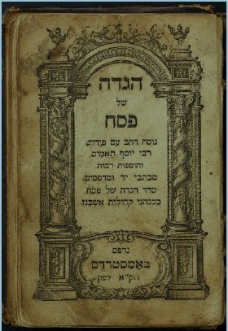
“On the way home, I stopped at the post office to collect my mail.” He paused. “Your envelope was waiting for me. That check,” Reb Shaul said through tears, “saved the yeshivah. It allowed us to continue operating.”
Today, nearly fifty years later, Kiryat Chinuch L’Banim continues to flourish, having guided thousands of talmidim toward productive Torah lives.
Years later, Rabbi Munk’s son, Chaim Munk, experienced an extraordinary epilogue to the story. While attending a wedding in Baltimore, an Israeli Jew approached him and asked whether he might be able to drive him back to New Jersey. During the drive, the man mentioned that he was from Ashdod.
Chaim responded, “I know a Rav there,” and began recounting the remarkable story of the antique Haggadah and the donation that had kept the institution alive.
Before he could finish, the passenger interrupted him. “I was there,” he said quietly. “I was one of the rebbeim in that yeshivah. I was sitting in that very meeting when Reb Shaul told us that the school had reached the end of the road and would have to close.” He paused, overcome by the memory. “And then your father’s check arrived.”
A treasured Haggadah had been preserved by one family for generations. It could easily have remained nothing more than a valuable collector’s item. Instead, following the Steipler’s guidance, it became the catalyst that saved a Torah institution, one whose influence continues to be felt by thousands of Jewish lives to this very day.

Reprinted from the Parshas Ki Seitzei 5786 email of Zichru Toras Moshe.

The Cold-Harded
Non-Jewish Businessman
By Yoni Schwartz

Rav Eliyahu Mizrachi, the author of the famous commentary on Rashi, once told a story that he heard firsthand. Many years ago, when Turkey was under Islamic rule, he was in the Turkish town of Izmir and came across a businessman who had what he described as “a crown of light” on his head.
He asked this man what his story was, and he replied with the following: “I wasn’t always Jewish and used to be a coldhearted businessman. In Izmir there is a well-known widow who goes around all day limping on her cane to collect for the poor. She was sweet and very trusted by the townspeople.
One day, as I was with my friends, I thought it would be funny to hand her some pebbles instead of money. Well, when I did so, she said, ‘I bless you that when you need the Jews, they will not close their hand on you.’ I got very upset and began cursing her in public.
Well, in the years after that, my business went south, and I lost everything - to the point where I couldn’t afford a meal. My old friends didn’t help me, even though they were as wealthy as I used to be. When I was walking around Izmir one day, I saw that someone from the shul was giving out food to the poor townspeople for Shabbos, so I waited in line. When my turn came, the gabbai responded, ‘I’m sorry, but this isn’t my food to give out freely. It’s only for Jews. However, I can give you from my own money.’
As I sat there eating, I cried bitterly, remembering the words of that sweet old woman. I decided that I wanted to convert and mend my crooked ways. However, the rabbi of the town didn’t trust me. As he was about to turn me down, that holy woman walked in and testified that I was sincere. Since then, I’ve seen my business succeed once more, and I’ve been working very hard to give as much tzedakah as I can and always be honest in business. I also opened a food pantry for those who struggle.”

Reprinted from the Parshas Shoftim 5786 email of Torah Sweets

The Power of a Commitment to
Never Lie Again

A man once came to the Chozeh of Lublin, zt”l. This person was filled with Aveiros, and he asked the Chozeh to show him the way to do Teshuvah. The man fully expected the Chozeh to tell him to fast and seclude himself, but to his amazement, the Chozeh told him that in order for him to do Teshuvah, he must be extremely careful that no false word leave his mouth.
The man was surprised at this advice and asked, “If I accept this upon myself and I am careful not to lie, will my Teshuvah be accepted?”
The Chozeh responded that it definitely would. When he heard this, the man completely accepted upon himself that no lie would ever leave his mouth.
The next day this man left his house in the dark of night, with the intent to go out and steal. On his way, he met a friend, and the friend asked him where he was going. He immediately remembered that he was not allowed to lie, and not wanting to say what he was about to do, he said he was on his way home, and he proceeded to return to his house.
The next night he went out to commit another Aveirah, and again he met a friend who asked him where he was headed, and the same thing happened, and he returned home. This happened every time that he wanted to sin, and in this way, he became a complete Baal Teshuvah.
Rav Pinchas of Koritz, zt”l, quoting Rav Zusia, zt”l, teaches that if one says
even one false word, he immediately distances himself from Hashem. It is written in Igeres HaGra, that a person should not train his children with strictness, except for when it comes to lying. If a person sees that his child lies, he should act severely, because the Torah says that one must distance himself from a false word.
Rav Gamliel Rabbinowitz writes that we must discuss honesty and being careful about telling lies with our children, and we must exert much effort in training them to be very careful with any speech that comes out of their mouths.
The main thing, however, is that children see the example set by the parents who themselves, are very careful with this, and this is how they will learn what to do!
Reprinted from the Parshas Ki Seitzei 5786 email of Rabbi Yehuda Winzelberg’s Torah U’ Tefilah.

The Chasam Sofer’s
Miracle Candles
By Yehuda Z Klitnick

The heilige Gaon Harav Moshe Sofer Ztzal, the Chasam Sofer, was plunged into grief and sorrow when all his sons and daughters—one after another—fell sick with severe illnesses. The physicians were powerless to help, and as the family began to lose hope, most of the children began showing signs of recovery. Day by day, they
regained their health. Laughter and joy returned to the household.
However, not all was well. Two of the children remained critically ill, their conditions pale and fragile. Their high fevers and agonizing pains defied all medical treatment. These were the two eldest sons—the young boy Shmuel Binyamin, later author of the Ksav Sofer, and his younger brother Yitzchok Leib later author of the Michtov Sofer.
Days passed and conditions worsened. The young boy Shmuel Binyamin lost consciousness entirely. He was no longer the brilliant child; he was now an eight-year-old boy, suffering in severe agony. Day by day, various complications set in. For seven long, agonizing days, different symptoms attacked his weakened body at once, him to the brink of death. The situation of the boy was critical, and the city’s top physicians threw up their hands in helplessness.
The family's prayers and tears broke through the heavens. Yeshiva students fasted, recited Tehilim, and learned round the clock. Everyone joined in fervent prayer for the son of their beloved leader. During this time, the Chasam Sofer added the name Avraham Shmuel Binyamin.

The Doctors’ Despair
The greatest doctors called to his bedside stood helpless before the dying child. Seeing the initial signs of death, they threw their hands up in despair and whispered in low tones: Shmuel Binyamin has only hours left to live. We have done all we can. Our job is done—we now yield to the Chevra Kadisha.

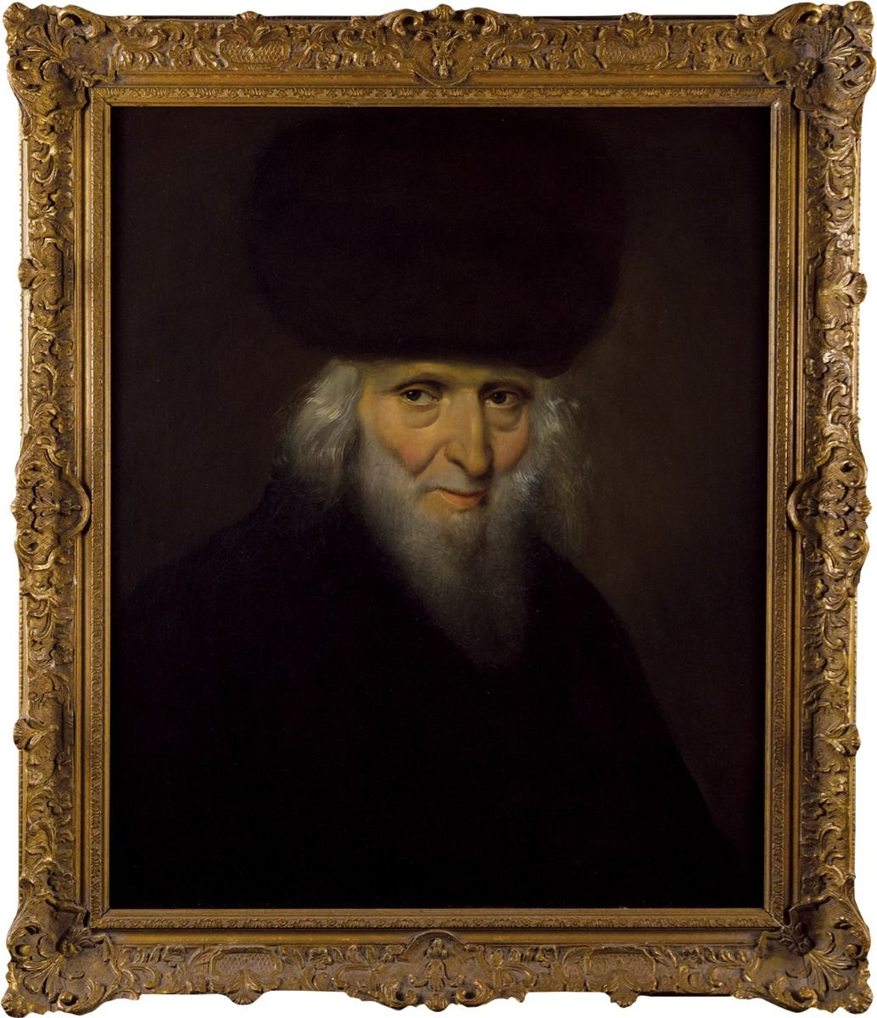
Portrait of the Chasam Sofer by Josef
Edward August von Gillern, circa 1835

The disciples of the Chasam Sofer, standing by the dying child’s bed, felt their souls nearly leave them upon hearing the bitter news. They quickly ran to the holy Chasam Sofer, interrupting his regular lecture. Softly, they reported: "Rebbe, thus said the doctors..."
The holy face of the Chasam Sofer darkened with pain. He kissed his Talmud, which lay open before him, stood up, and rushed to his son’s room. Upon entering, a heartbreaking scene met his eyes: his child lay in bed, pale, breathing with difficulty, showing all the agony of a soul near departure. Yet, what caught his focus were the candles—the very candles lit by the Chevra Kadisha around the child’s bed, as was customary during the departure of a soul... The members of the Chevra Kadisha stood in the room, their eyes cast down, whispering the customary prayers for a dying person.

Father's Prayer
The Rav's family, close students, and devotion-filled followers stood crying in the corners of the room. Tears streamed down every cheek as they awaited the grim moment... Our holy Master looked on with deep pain—a pain far beyond human endurance.
Suddenly, the child's father turned to the doctors and declared: "We are in the
hands of the Almighty. Although you failed in your duty, our Master in Heaven can perform miracles!"
Hearing the father’s steadfast faith, the top doctor bowed his head in awe. He gathered his books and medical bags, which were already packed, and laid his hands upon the sacred manuscripts written by the Chasam Sofer himself. With deep emotion, he exclaimed: "May Hashem look upon your holy Torah and answer your prayers!"
When the doctor finished speaking, the holy face of the Chasam Sofer radiated. He whispered softly: "Blessed is the True Judge," and declared in words that left the onlookers stunned:
"It is impossible that I should live to eighty and my son not live to carry my burden after me!" Not a few moments passed, and the fragile child opened his eyes! The doctors stood in absolute astonishment at the miracle unfolding before their eyes: the fever broke, the boy's strength returned, and slowly, his color restored. Gradually, he made a full recovery!
And indeed, fifty years later, when the Ksav Sofer was seventy-three years old, he departed to the eternal world—exactly thirty-three years after his father's passing in Pressburg. His father's decree and prayer had been fulfilled!

The Sacred Heritage of the Candles
Years later, when the Ksav Sofer reached an advanced age, Rabbi Ber Frank, head of the Chevra Kadisha in town, gave him those very candles that had been lit by his bedside during his childhood illness. These candles symbolized the darkest moments and the grand miracle that followed. They were meticulously crafted by a master artisan, placed in a beautiful ornamental box, and given as a gift to the head of the burial society for safekeeping through the generations. Today, these holy candles remain preserved in the hands of his grandson, the Pressburger Rosh Yeshiva in Jerusalem.

Reprinted from the Parshas Ki Seitzei 5786 email of Pardes Yehuda.
The Ksav Sofer’s Segulah

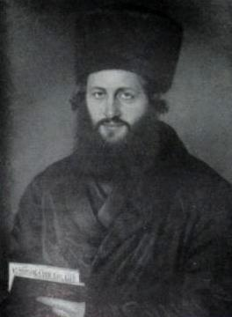
The Ksav Sofer

Rav Yitzchak Zilberstein, Shlit”a, once related a story that happened with the Ksav Sofer. A Jew in the city of Pressburg became gravely ill and it became clear that there was not much time left for him. The most prominent physicians were consulted and various drugs were administered, but it was to no avail, and his condition did not get better.
The members of the family were G-d-fearing Jews who understood that one does not give up hope, but rather he places his trust in Hashem, the Healer of all flesh. The children of this sick individual went to the Rav of the city, the holy Ksav Sofer, and after relating the patient's history and the present situation, they implored him for a Brachah, a blessing that would intercede in the Heavenly Court, so that their father would live.
The Ksav Sofer listened, and suddenly took off the scarf that was wrapped around his neck, and handed it to the family members. He said, “Here, take this scarf and place it on the forehead of the patient, and with the help of Hashem, he will arise from his illness!”
The family did as the Ksav Sofer advised them, and soon enough, with the help of Hashem, the patient was completely cured! It was a miracle! The students who were always present in the Ksav Sofer’s home questioned him concerning the "holy" scarf. Did he perhaps "treat" it with the holy Names of Hashem? Was it immersed in Kabbalah?
The Ksav Sofer shook his head and said, “I have been wearing this scarf for a long time. It rests on my shoulders, as I constantly learn Torah. It is a part of my routine of Torah study, and Torah is the greatest healer of all ills. I felt that the scarf contained within it enough Kedushah to provide the medicinal and therapeutic qualities that were necessary to heal the patient. It has soaked up and absorbed so much Torah that it can heal someone who is sick!”

Reprinted from the Parshas Ki Seitzei 5786 email of Rabbi Yehuda Winzelberg’s Torah U’ Tefilah.

Rabbi Avraham Yaakov Friedman – First Grand Rebbe of Sadigur

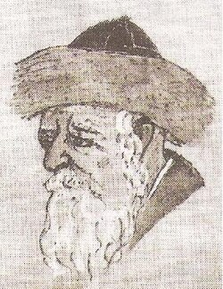

The Rebbe of Sadigur was in jail and the Russian government was in no hurry to pursue the investigation. Government officials still smarted from the memory of how the Sadigurer's father, the "holy Ruziner" Rebbe, had escaped through their fingers. They would get their revenge now, through his son. The chief prison warden was an anti-Semite. He didn't care that the Rebbe was innocent or that the Rebbe had been cruelly torn from his loving family and his devoted followers. Nor did he mind if the Rebbe suffered physical hardships in prison.

The Chief Warden’s Pleasure on Inflicting Misery on the Rebbe
On the contrary. He found a special pleasure in inflicting misery upon the Rebbe. The warden put the Rebbe in a dark and tiny prison cell. No windows let in the light of day. There was nothing to sit on. All day long the Rebbe had to stand. At night one of the guards unlocked and unfolded a shelf from the wall, and that was the prisoner's bed. Next door to the prison stood a church. At regular intervals the church bells tolled, disturbing the prayers and meditation of the Rebbe.
He would close his ears tight so that the noise would not interfere with his prayers. He had to do this many times each day. The Rebbe was forced to share his narrow cell with a roommate, a vile Ukrainian, Jew-hating hoodlum who ridiculed and insulted the Rebbe continuously. Coarse faced, course-tongued, and repulsive to look at, he made the Rebbe's life miserable.

The Thug Refused to Allow the Rebbe to Use the Sofa
When the Sadigurer Chassidim bribed the prison guards to allow a sofa to be placed in the cell for the Rebbe to sit and sleep on, the thug did not let the Rebbe sit there. Instead, he sat there himself. At night when the Rebbe began to study, the Ukrainian criminal would holler in protest, "He's not letting me sleep," until the Rebbe had to give up and lie down resignedly on his hard shelf.
The chief warden was delighted with the Ukrainian's pranks. The hoodlum had known what to do even without the warden's having to tell him anything. As a reward, the chief warden doubled his food portions. Seeing that he was rewarded for his mischief, the Ukrainian thought of new ways to torture the Rebbe. When the Rebbe prayed, the thug would sing at the top of his lungs. This made it very difficult for the Rebbe to concentrate on his prayers.
Somehow the Ukranian knew that this was the cruelest form of torture he could inflict on his fellow prisoner, for the Rebbe suffered more from this than he did from any physical pain. One day while the Rebbe was reciting the morning prayers, the Ukrainian was acting particularly obnoxious, hurling insults, cursing, and singing coarse Ukrainian songs.
The Rebbe could not take it anymore. He could bear physical deprivation, but not this. What meaning did life have if he could not daven to Hashem with devotion? This was the final straw. The Rebbe came to the place in the prayers with the following verse: "Look out from Heaven and see How scorned and disgraced we are by the nations; Nevertheless, we have not forgotten Your name Please do not forget us either."
Over and over the Sadigurer repeated these verses. Suddenly a change came over the Ukrainian. He became very agitated. He threw himself wildly against the walls of the room, tearing out clumps of hair from his head. At first he could not speak. When at last he recovered the power of speech, he shrieked. "Help me! He's killing me! Save me!" His screams echoed down the dark prison halls. The guards came running to see what happened. The strangest sight met their eyes. The Rebbe stood calm and unmoving in one corner of the cell, his face to the wall, wrapped in a tallis. Meanwhile the hoodlum was flinging himself in terror and screaming, "Get me out of here! He's killing me! He's tearing me apart, limb from limb!"

The Guard Didn’t Know What to Do
A guard ran to the office of the chief warden to ask him what to do. He was shocked to see the chief warden acting much the same as the Ukrainian, writhing on the floor in agony. "Oh, no! Both of them!" thought the guard. He sped back to the Rebbe's cell, unlocked the door, and pushed the Ukrainian with all his might until he got him through the door and out into the hall. As soon as the Ukrainian was out, he stopped screaming and subsided into quiet. Now that the Ukrainian prisoner was out of danger, the guard ran back to see how the chief warden was doing. Lo and behold, he too was coming out of his strange fit. After that, the Ukrainian adamantly refused to set foot into the Rebbe's cell. He was afraid for his life.
The chief warden, realizing he had been punished for afflicting the holy man, humbly begged the Sadgurer for forgiveness. To show that he really meant it, he transferred the Rebbe to a larger, sunlit cell with a chair and a comfortable bed. He wanted to do more for the Rebbe. He asked him, "What else can I do for you? As long as I am within the prison rules, I will do anything for you."

The Rebbe’s Two Requests
The Rebbe requested two things; first, that his gabbai be permitted to stay with him, and second that on Shabbos and Yom Tov a minyan of Yidden come so he could daven Tefillah Be’Tzibbur. The warden promptly acceded to his requests.
Eventually the investigation was completed. The Sadgurer Rebbe was found innocent and released. But the suffering had taken its toll upon him. After having stood on his feet for days and weeks, his feet had grown weak. They never regained their former strength. And from closing his ears so tightly, he suffered the rest of his life from painful earaches.

Reprinted from the Parshas Ki Seitzei 5786 email of Inspired by a Story by Rabbi Dovid Caro.
A Drop of Water
Rav Yitzchok of Vorka zy”a once delivered a drasha about the importance of honesty in business. He criticized the practice of milkmen who water down the milk or grocers who put salt into the sugar and the like. He concluded by saying, “The pasuk says that one who does not do things like that will merit a long life. How can anyone not take that seriously?”
There was a milkman who was present during the speech. He realized that he had been acting wrongly, as he had always watered down his milk. He decided then and there never to do that again. However, the next day his customers complained that his milk didn’t taste as good or became spoiled.
The milkman approached the Rebbe and told him that he had done what was right but it had ruined his milk! The Rebbe told him, “You should know, my son, that since the sin of the eitz hadaas, good and bad are mixed together, and the world cannot live with only goodness. What you should do is to put one drop of water into the milk fulfill the obligation to have a bit of bad mixed with the good.”
******************************************************************
Rav Moshe Chaim Rothenberg zt”l, the brother of the Chidushei Harim, was a wealthy and generous chasid. A poor man once approached him with a letter from the Kotzker Rebbe zy”a, which contained a request to generously help this man with the wedding expenses for his daughter. Rav Moshe Chaim read the letter but he only gave the man one ruble and wished him well. The poor man was shocked by how small the donation was, and he said, “My travel expenses alone were much more than one ruble!”
But Rav Moshe Chaim would not give him any more money and, with no other choice, the man left his home with a broken spirit. As he walked out the door, he realized that he couldn’t rely on anyone other than Hashem to help him.
A few seconds later, he saw Rav Moshe Chaim’s attendant running after him. The attendant handed him a large amount of money, enough to cover all the wedding expenses. The poor man was now flabbergasted, and he decided that he had to go back and ask Rav Moshe Chaim for an explanation. He knocked on his door and asked him, “Why did you first give me such a small donation and then such a large one? Did you change your mind about how much you wanted to give?”
Rav Moshe Chaim replied, “When you first came with the Rebbe’s letter, I could see that you were relying on me and that you thought I’d certainly give you the full amount you needed. It seemed like you had forgotten that there is a G-d who is the only One you should rely on. Therefore, I sent you away with very little so that you would remember that you should only trust in Hashem, and then I gave you the full donation.”

Reprinted from the Parshas Ki Teitzei 5786 email of The Way of Emunah: Collected Thoughts on the Weekly Parshah by Rabbi Isamar Rosenbaum.

